FILE SYSTEM HIERARCHY

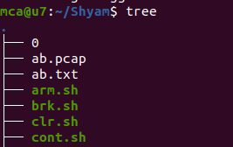

**/bin**

The '/bin' directory contains user binaries, executable files, Linux commands that are used in single user mode, and common commands that are used by all the users

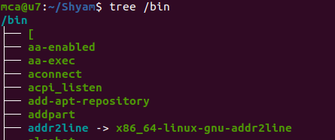

**/boot**

The /boot/ directory contains static files required to boot the system, such as the Linux kernel. These files are essential for the system to boot properly.

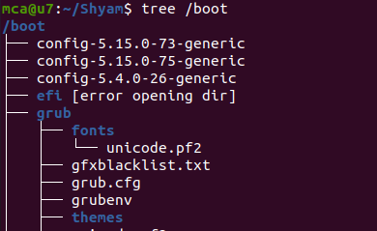

**/dev/**

The /dev/ directory contains device files representing the physical and virtual devices such as harddrives, printers, cpu etc..

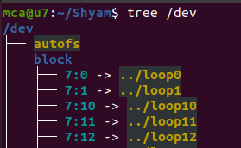

**/etc/**

The /etc/ directory is reserved for configuration files for various applications and services.

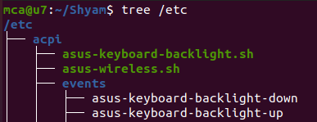

**/home**

It is the home directory for regular users.

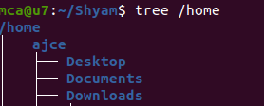

**/lib**

The /lib/ directory should contain only those libraries needed to execute the binaries in /bin/ and /sbin/.

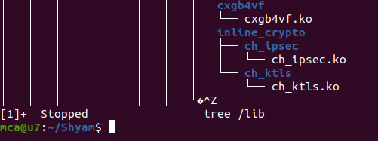

**/mnt**

temporary file attachment systems , eg: External drives, network shares.

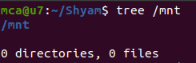

**/media**

Temporary mount system for Removable media eg: usb , optical disk , external hard drives

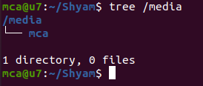

**/opt**

for storing optional packages

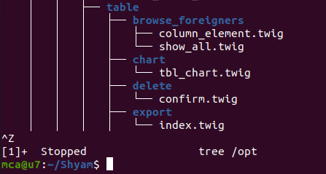

**sys**

Exposes informations about system hardware and devices

